
DOI: 10.22144/ctujoisd.2026.x
Design of an IoT system for monitoring and early warning of tilting and subsidence in high voltage electrical equipment
Pham Ngoc Luat^{1*}, Tran Huu Danh¹, Tran Nguyen Hien¹ and Tran Thanh Quang¹
¹Faculty of Electronics and Telecommunications, College of Engineering, Can Tho university, Viet Nam
*Corresponding author (pnluat@ctu.edu.vn)
- Article Info. |  | - ABSTRACT
Received dd MMM yyyy  Revised dd MMM yyyy  Accepted dd MMM yyyy |  | Structural stability monitoring of electrical equipment foundations in high-voltage substations is essential for grid reliability. However, continuous field assessment remains challenging due to severe electromagnetic interference (EMI) and harsh operational environments. This paper presents an autonomous real-time tilt monitoring system utilizing an MPU-6050 sensor, deployed on a 110kV circuit breaker foundation at the Can Tho 220kV Substation to assess structural stability after 8 years of operational service. The system architecture features a solar-powered field Node unit and a Master control unit positioned 200 m away inside the control room. Continuous 66-hour experimental field data confirm superior foundation stability, exhibiting minimal tilt variations (less than 0.04 degree) with mean tilt angles along the X, Y, and Z axes of 0.080, 0.140, and 0.160, respectively and a total absolute tilt angle of about 0.16 degree. By integrating complementary and Kalman filtering algorithms, high-frequency noise and cumulative zero-drift were effectively suppressed in the high-EMI environment. Additionally, the standalone solar power system maintained continuous operation across a daily voltage range of 13.24 V to 14.42 V, ensuring 24/7 autonomous reliability. This research provides a highly reliable, cost-effective framework for structural health monitoring of substation equipment in modern power grids.
  - Keywords
Tower Inclination, Tilt Sensor, MPU-6050, Electrical Equipment, Dashboard, ESP32, IoT, LoRaCommunication

INTRODUCTION
Along with advances in science and technology, the application of automated machinery to production processes—and specifically to equipment condition monitoring—has become increasingly widespread. Automated monitoring solutions are now deployed across a variety of industries. In Vietnam, several studies have explored structural tilt and settlement monitoring. For instance, Luong Ngoc Dung et al. (2021) introduced Tiltmeter monitoring technology, detailing its measurement, calculation, and analysis methods, while comparing it with horizontal distance measurement for vertical structural tilt and geometric leveling. Additionally, Luong Ngoc Dung et al. (2020) presented the application of inclinometer technology in confined spaces. However, these methods are primarily tailored for structural tilt monitoring in civil engineering construction. To the best of the authors' knowledge, there is currently no specific domestic research on the design of IoT-based early warning systems for monitoring the tilt and settlement of electrical equipment in 220kV and 500kV substations.
The application of automation to monitoring and evaluating the tilt and settlement of high-voltage transmission towers has also drawn significant attention from the global research community. Ruhai Liu et al. (2021) proposed an online tilt monitoring method for transmission towers using images and point clouds acquired by Unmanned Aerial Vehicles (UAVs). Based on this approach, a multi-scale classifier was constructed to automate the classification of point cloud data, thereby determining tower tilt. Subsequently, Yongseng Yang et al. (2023) suggested a camera-based tilt monitoring method that relies on the geometric shape and contour of the towers. Additionally, Zhumao Lu et al. (2022) presented a study using UAV-mounted LiDAR to assess tower tilt status based on point clouds from the tower top and body. Guangxin Zhang et al. (2023) proposed a real-time monitoring method for transmission tower tilt and foundation stability based on acceleration sensors. Furthermore, Liuhuo Wang et al. (2021) developed a solution using an excitation device, wireless sensors, and a monitoring server to record the horizontal vibrations of power line towers. Meanwhile, Xie Hu et al (2021) proposed a real–time warning model of transmission tower tilt based on tension and tilt senors. Moreover, Claudio Ferreira Dias et al (2021) combined data from multiple sensors to the framework to estimate the structural health of the tower against failures. Kun Qian et al (2025) proposed a PSOGRNN-based monitoring method to estimate the tilt of the transmission tower. However, these studies rely on complex computational models and require high initial investments for data acquisition equipment.
Substations operating at 220kV and 500kV play a crucial role in the national power transmission grid. These substations are surveyed, designed, constructed, and commissioned in full compliance with governmental and industry regulations. However, during operation, certain equipment—such as disconnect switches, post insulators, current transformers, and voltage transformers-can experience tilt and settlement due to shifts in site layout and column foundations. When any of this equipment tilts, the busbar and conductor connections within a bay are altered; conductors may become overly taut or sagged, ultimately compromising the long-term operational integrity of the equipment. Therefore, continuous monitoring, assessment, and early warning of equipment tilt and settlement sent to station operators are essential to ensuring a safe, uninterrupted power supply. This study applies automation technology to power transmission grid operation management, thereby contributing to enhanced labor productivity and national energy security.
This study successfully designed an IoT-based system for early monitoring and warning of equipment foundation tilt and settlement in 220kV and 500kV substations, enabling timely corrective measures to ensure the safe operation of high-voltage electrical equipment. The system can transmit continuous real-time updates and send alerts - including equipment identity, tilt status, location, and timestamp - to the monitoring center via the Internet.

materials and method

System Overview
Figure 1 illustrates the overall architecture of the proposed remote monitoring system based on Internet of Things (IoT) technology, which is structured into three primary layers: the data acquisition layer (Node TWR-01), the gateway layer (Master unit), and the cloud service layer. At the data acquisition layer, the sensing node Node TWR-01 operates autonomously powered by an off-grid Solar Power System consisting of a solar panel, a charge controller, and a battery bank. An ESP32 microcontroller serves as the core processing unit, interfacing with an MPU-6050 tilt sensor, a temperature sensor, and a local OLED display module for real-time field visualization, while dynamically driving a cooling fan. The collected sensory data are preprocessed, packetized, and transmitted to the master station via the Long Range (LoRa) wireless communication protocol.
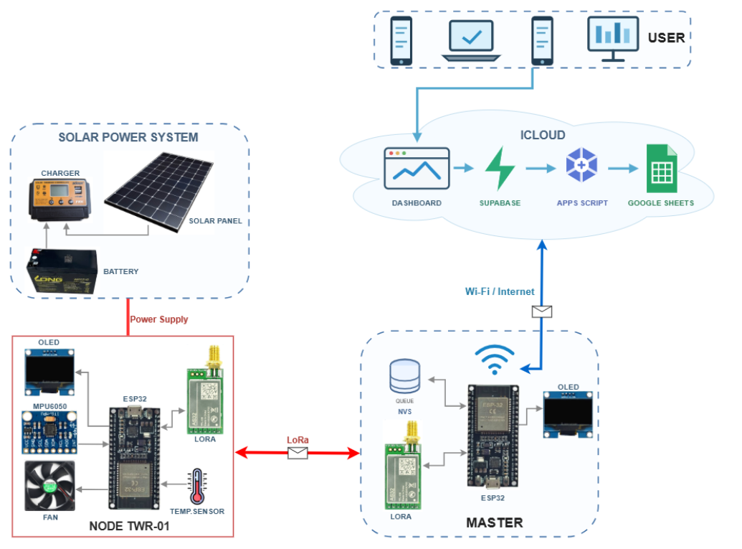
Figure 1. Overall system diagram
At the gateway layer (Master), a LoRa module receives the data packets and routes them to an onboard ESP32 controller, which is also connected to a dedicated OLED display for direct local status monitoring. To ensure data integrity during potential network outages, a Non-Volatile Storage queue mechanism (NVS Queue) is implemented for local data buffering. Upon establishing a Wi-Fi/Internet connection, the buffered and real-time data are transmitted to the cloud infrastructure. Within the cloud domain, a Supabase database handles structured data storage, working in tandem with Google Apps Script to automatically log historical records into Google Sheets, while simultaneously rendering real-time metrics on a Web Dashboard. Consequently, end users (USER) can monitor system status seamlessly across various terminal devices, including smartphones, tablets, and personal computers.
2.2. System Hardware Design
2.2.1. Master module
The block diagram and hardware configuration of the central gateway (Master Node) are illustrated in Figure 2.

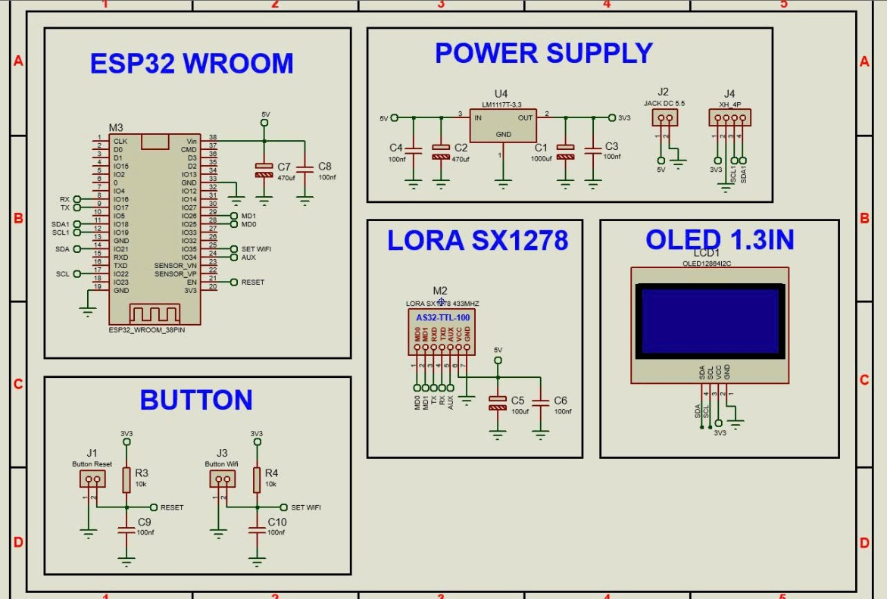
Figure 2. Schematic diagram of the master module

The gateway serves as a communication hub that collects wireless data from distributed sensor nodes and forwards it to the central management system. The circuit relies on an ESP32 WROOM microcontroller as the core processing unit, responsible for receiving data via a LoRa SX1278 module (AS32-TTL-100 IC, 433 MHz frequency) and processing it before transmission to the server over Wi-Fi connection. Real-time operational parameters and network status are locally displayed on a 1.3-inch OLED screen using the I2C communication protocol. The power supply unit receives a 5V DC input via a 5.5mm DC jack and employs an LM1117T-3.3 linear regulator alongside filtering capacitor networks (1000μF, 470μF, 100nF) to deliver a stable 3.3V rail for the microcontroller and peripheral components. Additionally, a dedicated button block consisting of Reset and Wi-Fi Configuration buttons allows operators to easily reboot the system or reconfigure network parameters.
2.2.2. Node module
The block diagram and operational principle of the inclination monitoring node are illustrated in Figure 3.

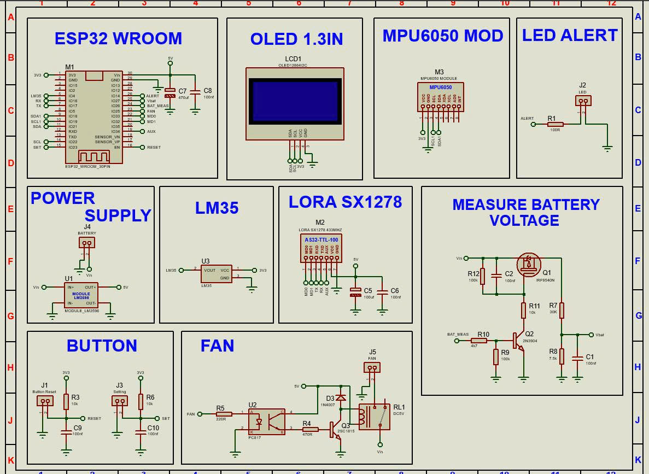

Figure 3. Schematic diagram of data processing and sensor module

The system utilizes an ESP32 WROOM central microcontroller for data acquisition, algorithmic processing, and communication management. Regarding data collection, the three-axis (X, Y, Z) inclination variations of the structure are captured via an MPU6050 6-axis accelerometer and gyroscope sensor connected through the I2C protocol. Concurrently, the ambient temperature inside the technical enclosure is monitored using an LM35 analog sensor. Once processed, the data is displayed directly on a 1.3-inch OLED screen and packaged for long-range, low-power wireless transmission to the central gateway via a LoRa SX1278 module (AS32 IC, 433 MHz frequency band).
To ensure system reliability and long-term operation, the node integrates a power management unit and automatic actuation circuitry. Primary power supplied from a battery or accumulator is stepped down to a stable 5V output using an LM2596 module. The battery voltage measurement circuit is specifically designed with an NPN transistor (2N3904), a P-MOSFET (IRF9540N), and a voltage divider (30 kΩ/ 7.5kΩ). This configuration enables the microcontroller to periodically trigger the measurement circuit via the Vbat pin and read the value through an ADC channel (BAT_MEAS), effectively eliminating static leakage current to optimize power consumption. Furthermore, if the measured inclination angle exceeds the safety threshold, the microcontroller triggers an LED indicator (D4). In cases where the internal temperature surpasses a predefined limit, a control signal from the FAN pin energizes a relay through an optocoupler (PC817) isolation circuit and a transistor (2SC1815) to operate a 5V cooling fan, ensuring stable system operation under harsh environmental conditions.
2.2.3. Power solution
In this study, the system operates on solar power, utilizing a 30W photovoltaic panel paired with a 30A MPPT charge controller to recharge a 12.8 VDC, 12Ah LiFePO₄ battery pack. The MPPT controller was chosen for its superior efficiency, particularly in fluctuating weather or low-light conditions, where it delivers a 20–30% performance boost over traditional PWM technology to maximize energy yield. Upon reaching full charge, the battery pack provides sufficient power to sustain continuous operation for over 18 days. Assuming an 80% charging efficiency alongside an average of six daily peak sun hours, the battery can achieve a complete recharge cycle. These estimations are derived using Equations (1) and (2):
$T=\frac{C}{Ps}= \frac{153.6}{0.35} ≈18 \left(days\right)$ (1)
$Tfc=\frac{C}{Pr * 0.8}= \frac{153.6}{30*0.8} ≈6.4 (hours)$ (2)
whereas,
• T: Duration the system can operate using the battery’s energy (in days)
• Tfc: Time required to fully charge the battery using the solar panel (in hours)
• C: Battery capacity (C = 153.6 Wh)
• Ps: Power consumption of the entire system (Ps = 0.35 W)
• Pr: Power rating of the solar panel (W = 30 W)
2.3. System Software Design
2.3.1. System implementation
Figure 4 illustrates the operational flowchart of the LoRa sensor node, highlighting the sequence of data acquisition, power management, and retransmission mechanisms designed to ensure reliable communication while preserving energy.

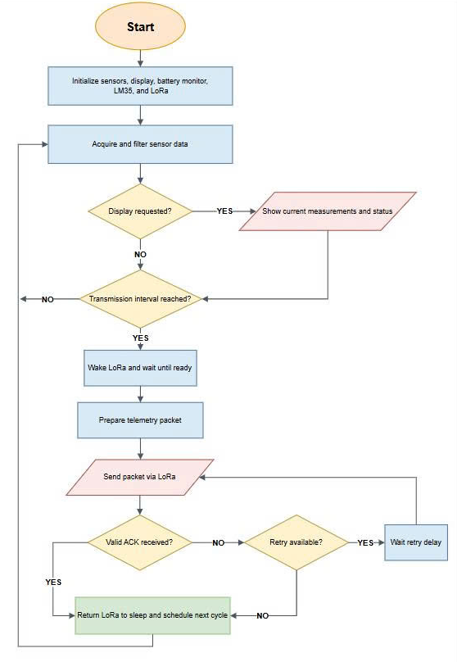

Figure 4. Operation flowchart algorithm of the sensor node

- System Initialization and Data Acquisition: The operational workflow of the system begins with the initialization of the hardware modules, including the sensors, display, battery monitor, LM35 temperature sensor, and LoRa transceiver. Upon completing initialization, the system acquires and filters sensor data to minimize noise and improve measurement accuracy. The microcontroller then checks whether a display request has been triggered. If requested, the current measurements and operational status are presented on the display; otherwise, the system evaluates whether the designated transmission interval has elapsed. If the interval has not been reached, the system loops back to continue acquiring and processing sensor data.
- LoRa Data Transmission and Power Management: When the predefined transmission interval is reached, the microcontroller wakes the LoRa module from sleep mode and waits until it is operational. The sensor data are then structured into a telemetry packet and transmitted via LoRa. Following packet transmission, the system waits for an acknowledgment signal. Upon receiving a valid ACK, the LoRa module is immediately returned to sleep mode to conserve power, and the next cycle is scheduled. If no valid ACK is received, the system verifies the availability of retransmission attempts. If retries remain, the microcontroller waits for a specified delay before retransmitting the packet. Otherwise, if the maximum retry limit is reached, the system aborts the transmission, places the LoRa module back into sleep mode, and transitions to the subsequent operational cycle to optimize overall energy efficiency.
At the edge network tier, the data ingestion and cloud synchronization framework on the LoRa Gateway is structured around a dual-threaded asynchronous architecture. This functional decoupling optimizes real-time packet acquisition while enforcing rigorous Data Loss Prevention (DLP) protocols.
- System Initialization, LoRa Packet Reception, and Telemetry Staging: The gateway initializes the OLED display, LoRa receiver, persistent FIFO queue, and Wi-Fi sub-systems while maintaining network connectivity and NTP sync. Upon receiving a LoRa packet, it verifies node validity and discards invalid ones. For valid packets, duplicate payloads trigger an immediate ACK re-transmission. Otherwise, if no unstored sample is pending, the telemetry is staged and validated. Valid telemetry is enqueued into persistent memory, triggering a success ACK and activating the cloud worker, while invalid or unqueued data is preserved or handled accordingly without advancing state.
- Queue Processing, Network Synchronization, and Cloud Transmission: The cloud task polls the persistent queue for pending records. When data is available, it validates network connectivity, Wi-Fi configuration, and NTP timestamp readiness before extracting a FIFO snapshot - processing single records or batches depending on queue size. The gateway establishes a secure TLS connection to transmit the HTTP/MQTT request. Successful transmissions flush the channel and purge processed records from the queue, whereas failed attempts retain the queued data and initiate retransmissions using an exponential backoff strategy.
2.3.2. Tilt benchmark
In compliance with the regulations of Vietnam Electricity (EVN) and pursuant to the National Technical Regulation on Electric Power Technical – Power Network (QCVN 26:2025/BCT) [11], the allowable lateral or longitudinal tilt limit for the equipment is calculated as $\frac{1}{200}$ of the equipment height. Consequently, the inclination angle in this scenario is determined as shown in Figure 5, which corresponds to approximately $β=\tan^{-1}(\frac{1}{200})≈0.287$ degrees and h is the height of the equipment. The initial data sample,${ θ}_{base}$, is automatically identified by the system and established as the baseline for comparison with subsequent collected values.
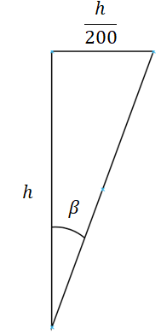
Figure 5. Inclination angle detection
Due to sensor measurement errors and physical limitations, an allowable threshold of $β≈0.3$ degrees, is proposed within the scope of this study to maintain a reasonable tilt warning mechanism. Furthermore, the system retrieves a moving average 10 most recent tilt measurements before comparing this processed value against the baseline. If the absolute difference between the newly collected value and the baseline exceeds the defined threshold, a warning is triggered. The monitoring scope encompasses both lateral tilt (along the X-axis) and longitudinal tilt (along the Y-axis) based on the assumed reference coordinate system illustrated in Figure 6.

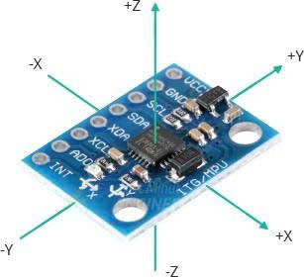
Figure 6. Coordinate system
To mitigate transient noise and environmental fluctuations, the moving average of the tilt angle $\overline{θ}$ is computed using the N = 10 most recent consecutive measurements:
$\overline{θ}= \frac{1}{N}\sum_{i=1}^{N}{θ_{i}}$ (3)
where $θ_{i}$ represents the raw sensor reading at sample index i. The alarm trigger condition is subsequently defined as:
$\left|\overline{θ}-θ_{base}> θ_{threshold}\right|$ (4)
where $θ_{base}$ is the initial reference angle recorded during system initialization, and $θ_{threshold}$ = 0.3⁰ denotes the maximum allowable tilt tolerance. This condition is evaluated independently along both orthogonal axes:
- Lateral tilt (X-axis):
$\left|\overline{θ_{x}}-θ_{base, x}> θ_{threshold}\right|$ (5)
- Longitudinal tilt (Y-axis):
$\left|\overline{θ_{y}}-θ_{base, y}> θ_{threshold}\right|$ (6)
An alert notification is immediately dispatched if either axis violates the threshold condition.
In addition, the system triggers a low-battery alert when the power supply voltage drops below 12 VDC to ensure stable system operation.
2.3.3. Web interface
Figure 7 shows the Web Dashboard interface of the system with a simulated value.

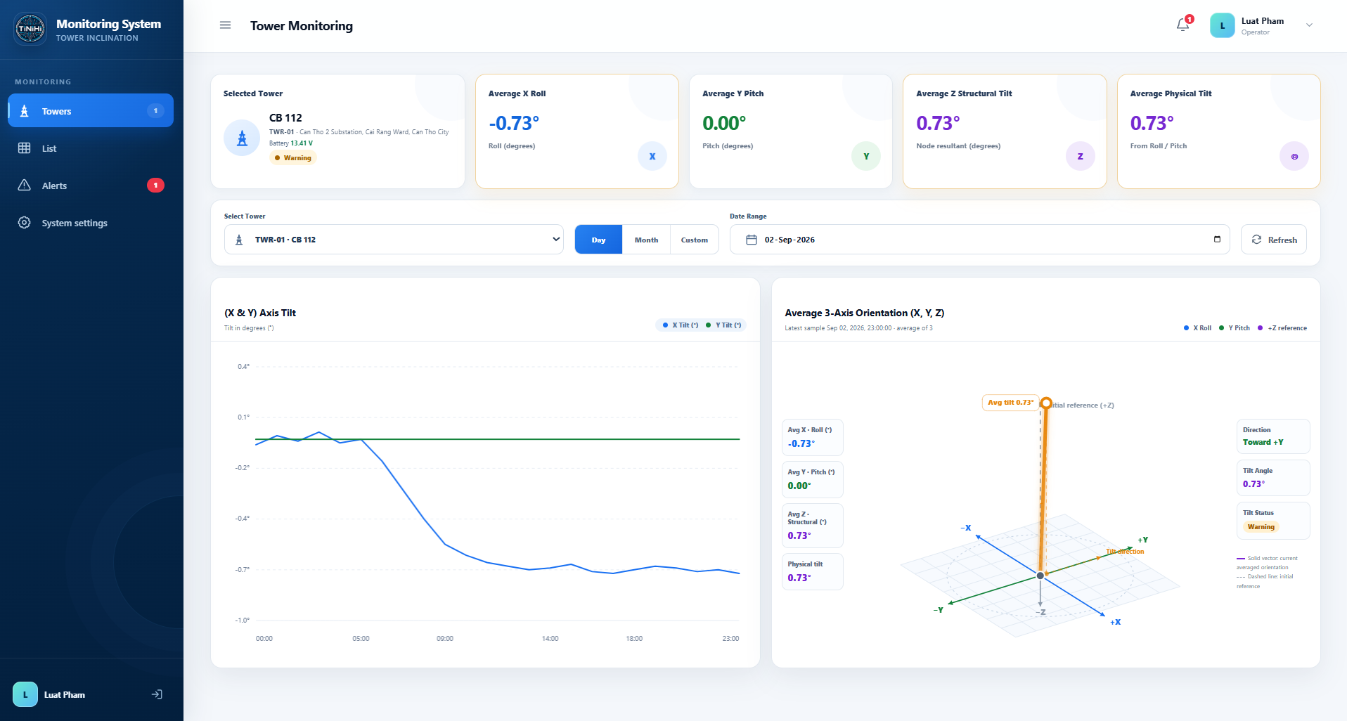
Figure 7. Web dashboard interface

The graphical user interface of the web dashboard (Tower Monitoring) is designed to visualize real-time transmission tower inclination parameters. The layout is structured into primary functional modules to facilitate continuous monitoring and rapid decision-making:
- Real-time Average Metrics Panel: The top section features a node identification card (CB 112) displaying its operational voltage and system status (Warning). Adjacent indicator cards continuously update the average inclination parameters, including the average roll angle (Average X Roll: -0.73⁰), average pitch angle (Average Y Pitch: 0.00⁰), structural tilt angle (Average Z Structural Tilt: 0.73⁰), and overall physical tilt (Average Physical Tilt: 0.73⁰).
- Time-series Trend Plot: The left panel ((X & Y) Axis Tilt) illustrates the dynamic behavior of the orthogonal tilt components (X, Y) over a 24-hour time axis. This plot enables operators to track continuous angular variations and identify mechanical deformation trends within the tower structure.
- 3D Spatial Orientation Model: The right panel (Average 3-Axis Orientation) renders the mean spatial tilt vector in a three-dimensional Cartesian coordinate system (X, Y, Z) relative to the true vertical reference axis (Initial reference +Z). An accompanying status panel presents real-time analytical metrics, including the deflection direction (Direction: Toward -Y), resultant inclination angle (Tilt Angle: 0.73⁰), and current safety level (Tilt Status: Warning).
3. RESULTS AND DISCUSSION
3.1. Complete system
Figure 8 shows the complete system with all components.
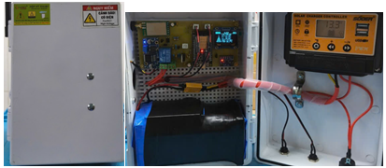
(a)
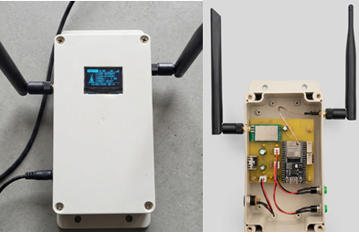
(b)
Figure 8. Complete system: a) Master; b) Node
Figure 8 illustrates the two primary subsystems of the proposed system: the central unit (Master) (Figure 8a) and the node sensor (Node) (Figure 8b), both housed in specialized, industrial-grade IP-rated enclosures to ensure long-term durability in harsh operational environments.
- Master Unit: Serves as the central data acquisition, processing, and management hub for the entire system. Its optimized internal hardware architecture comprises a main control board (integrating an ESP32 microcontroller and a wireless communication module), a power management unit paired with a high-capacity rechargeable Lithium-ion battery, isolated relays for load control, and an OLED display for real-time system status visualization.
- Node Unit: Responsible for field-level environmental data acquisition and operational parameter monitoring. Enclosed within the protective housing, the Node's hardware integrates a central microcontroller, a multi-sensor array (including a 3-axis accelerometer and a temperature-humidity sensor), and an optimized power management circuit. Furthermore, an integrated solar charger controller enables energy harvesting from an external solar panel to continuously recharge the internal battery pack.
To ensure high transmission reliability over long distances and robust anti-interference capabilities in industrial environments, both the Master and Node subsystems incorporate low-power, long-range wireless communication based on LoRa technology, coupled with external antenna systems optimized for RF radiation and wave propagation.
3.2. System evaluation
To evaluate the performance of the system, two main experiments were conducted: system stability testing with sensitivity testing of the MPU-6050 sensor, communication range and latency testing using LoRa technology. In addition, the electrical power supplied to the system throughout these experiments was derived entirely from a solar panel, which also served to evaluate the power generation capability of the solar panel for the system.
System Stability Test: In this experiment, the state of the MPU-6050 sensor was continuously recorded for 24 hours to assess system stability. Furthermore, simulated tilt variations were introduced to evaluate the system's alerting capability. Simulated tilt variations were carried out at various times of the day to assess the impact of sunlight under different light intensities.
The experimental results demonstrated that the system operated continuously and successfully detected tilt variations across the simulated scenarios at different times of the day. Figure 9 illustrates a simulated tilt event at the monitoring station. At this point, the tilt status was updated on the Web Dashboard interface (Figure 9a), and an alert email was dispatched to the preset address (Figure 9b). Additionally, the history of detected tilt angle changes at the monitoring station was logged into a Google Sheet, as shown in Figure 11c.
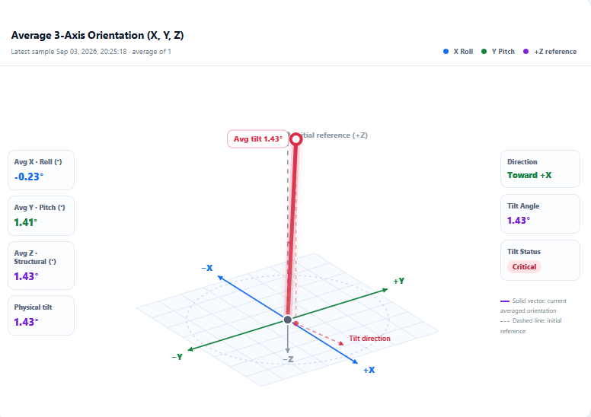
(a)
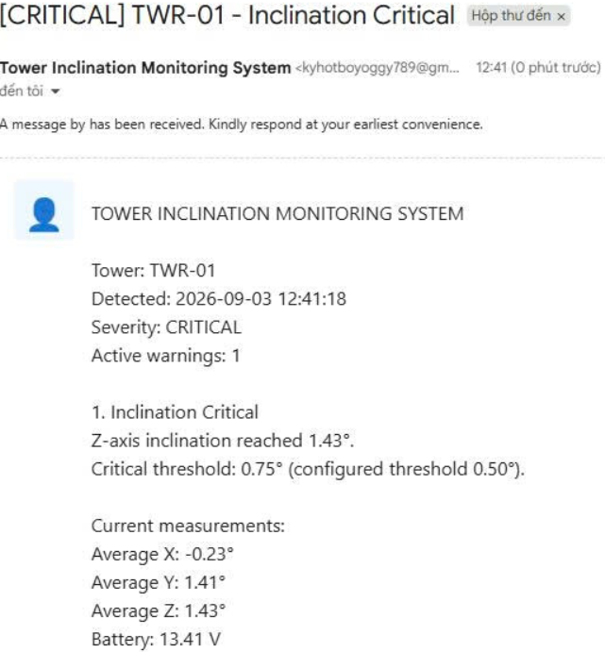
(b)
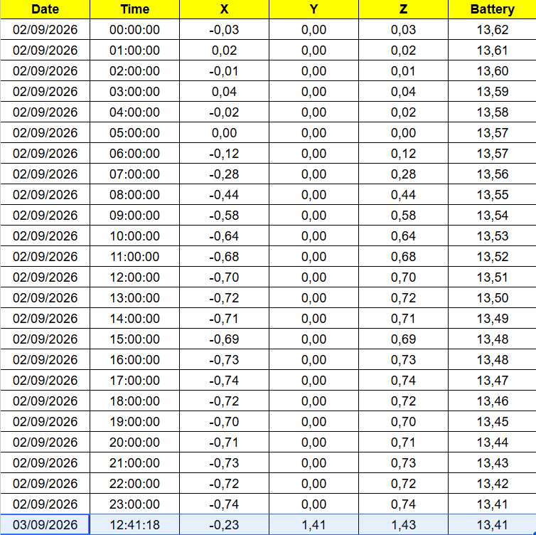
(c)
Figure 9. Tilt event: a) Tilt orientation on Web Dashboard; b) Warning email; c) Data in Google Sheet
LoRa Communication Range Evaluation: To determine the communication range of the LoRa protocol, the transmitter and receiver antennas were mounted 2 meters above ground level, with measurements conducted along a clear line-of-sight (LoS) path. Prior to testing, real-time synchronization was established between the transmitting and receiving devices. The transmitter then dispatched data packets to the receiver. At the receiving end, the packet loss rate (PLR) was estimated based on the number of missing packets. Transmission quality was deemed acceptable when the PLR remained below 20%. Detailed experimental data are presented in Table 1.
Table 1. LoRa communication range evaluation
Distance (km) | 0.1 | 0.5 | 1.0 | 1.5
Signal strength | Good | Good | Good | Bad
PLR (%) | 0 | 0 | 10 | 30
The empirical results demonstrate that the network operates stably and reliably within a range of up to 1.0 km under unobstructed conditions. When the distance between the Node and the Master unit expanded to approximately 1.5 km, transmission instability began to emerge. Beyond a 1.5 km radius, communication between the two devices was completely severed.
3.3. Security issues
To ensure operational security and data integrity, the centralized web interface enables real-time monitoring of supervisory stations through a multi-layered security framework. Access control employs a multi-factor authentication (MFA) mechanism combining secure passwords with biometric fingerprint scanning to eliminate spoofing risks. The system implements a role-based access control (RBAC) policy, granting core command execution privileges strictly to the central manager while restricting remaining accounts to view-only or minimal interaction modes.
For traceability and security auditing, the entire event chain-including login records, session durations, and operational commands-is automatically logged into a tamper-proof database with cryptographic timestamps. In the event of a network outage, an automated failover mechanism triggers local operational mode: operational data, violation logs, and local alarms continue to be securely cached in the monitoring station's local storage. Once connectivity is restored, an automated synchronization process executes back to the central server, ensuring data continuity and zero loss.
3.4. Actual Installation
3.4.1. Testing location
In the field experiment, the tilt monitoring system was installed at the base of a 110kV circuit breaker at the Can Tho 220kV Substation (Cai Rang Ward, Can Tho City) from September 8, 2026 to September 11, 2026 to evaluate the structural stability of the equipment foundation after 8 years of operation. Although post-installation monitoring results meet regulatory requirements, regular inspection and evaluation during operation remain necessary, with particular focus on the trend of foundation stability for the circuit breaker after more than 5,000 switching operations. Figure 10 shows the actual installation in this scenario.
In this experiment, the Node device containing the tilt sensor is installed at the equipment foundation as shown in Figure 10a, equipped with a solar power system to ensure continuous operation under adverse weather conditions. Meanwhile, the Master unit is placed inside the substation control house at a distance of approximately 200 meters, connected to the local power grid and Wi-Fi network as depicted in Figure 10b.
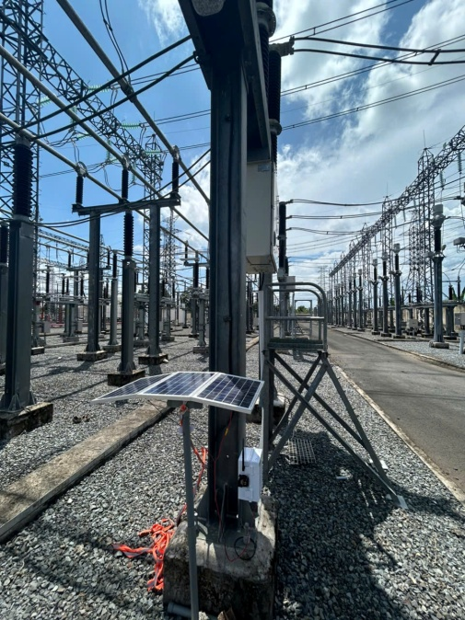
(a)
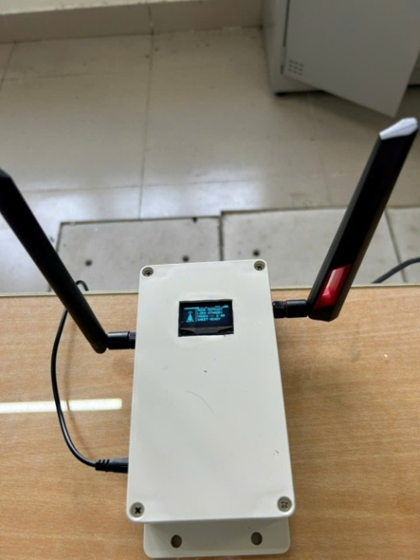
(b)
Figure 10. a) node sensor installation position; b) master location
3.4.2. Experimental results
The measured sensor data is converted into tilt angles and subsequently recorded in a Google Spreadsheet, as shown in Figure 11.
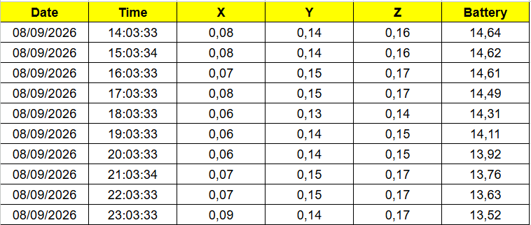
(a)
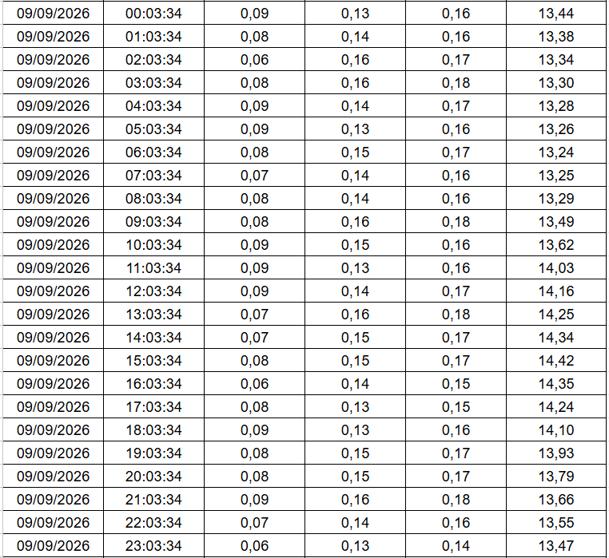
(b)
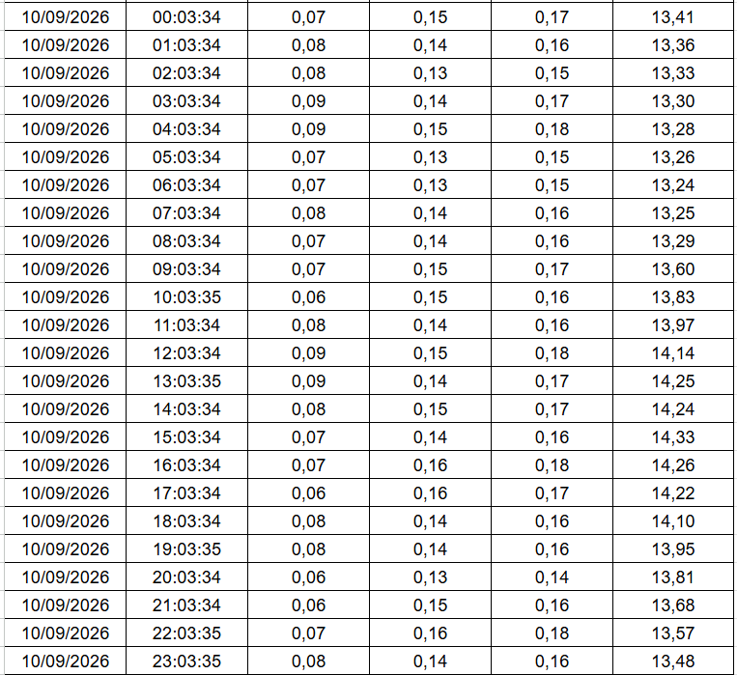
(c)
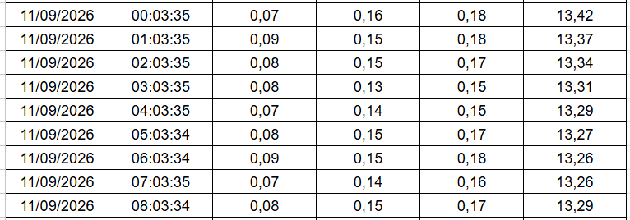
(d)
At the initial logging instance (14:03:33, September 8, 2026), the system recorded baseline values of 0.08 degree for X-axis tilt, 0.14 degree for Y-axis tilt, and a total resultant Z tilt of 0.16 degree, while the solar battery voltage was fully charged at 14.64 V.
Analysis of Structural Stability and Tilt Kinematic Behavior (X, Y, Z Axes): The continuous tilt monitoring results over a 66-hour cycle (from September 8, 2026, to September 11, 2026) in Figure 11a, 11b, 11c and 11d reflect the dynamic equilibrium state of the surveyed structure. Specifically, the tilt values along the three axes fluctuated within an extremely narrow margin: the X-axis recorded a range from 0.06 degre to 0.09 degree (mean value of 0.08 degree), the Y-axis from 0.13 degree to 0.16 degree (mean value of 0.14 degree), and the Z-axis from 0.14 degree to 0.18 degree (mean value of 0.16 degree). The maximum variation ranges on the respective axes reached only 0.03, 0.03, and 0.04 degree, confirming that the noise-filtering algorithm effectively eliminated high-frequency ambient noise components. The total absolute tilt angle of the structure remained stable around 0.16 degree, which is fully consistent with the observed Z-axis values. Notably, neither zero-drift nor cumulative error over time was observed, demonstrating the high stability and reliability of the MPU-6050 sensor system under actual field operating conditions.
Analysis of Cyclic Characteristics of the Power Management System (Battery Voltage): Parallel to the tilt parameters, the supply voltage time-series data exhibited a distinct day-night fluctuation pattern, characteristic of photovoltaic renewable energy systems. Throughout the 66-hour observation period, the supply voltage remained stable between 13.24 V and 14.42 V (mean value about 13.68 V). The minimum voltage drop was consistently recorded at 06:03 AM each day (13.24 V), corresponding to the end of the nighttime static discharge cycle. Immediately following solar irradiance exposure, the charging process proceeded continuously, reaching its peak at 03:03 PM (14.42 V on September 9 and 14.33 V on September 10). After 04:00 PM, the voltage began to decrease linearly as the system transitioned into the load-discharge mode. Operating consistently within a safe threshold (a maximum differential of only 1.18 V) ensures a continuous power supply and a constant reference voltage for the processor and sensors, thereby eliminating measurement errors induced by power supply fluctuations.
Figure 12 illustrates the measured parameters recorded during the experimental process on the Web Dashboard interface.

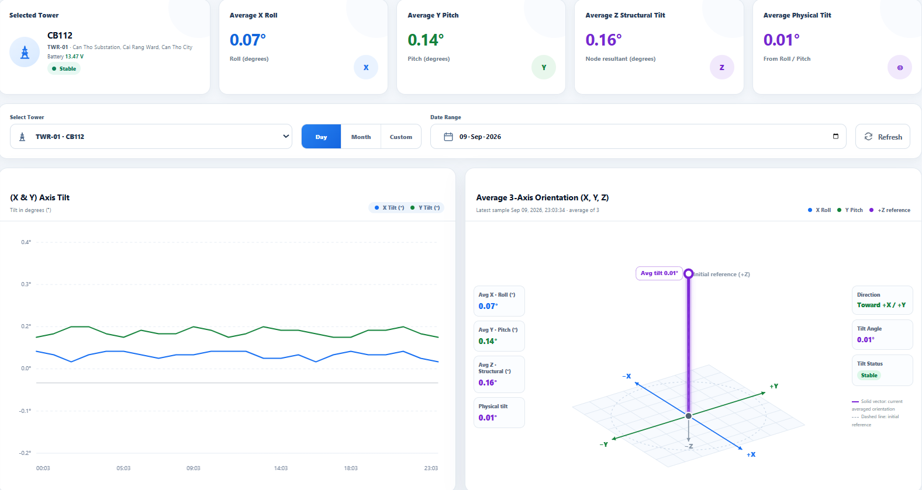

(a)

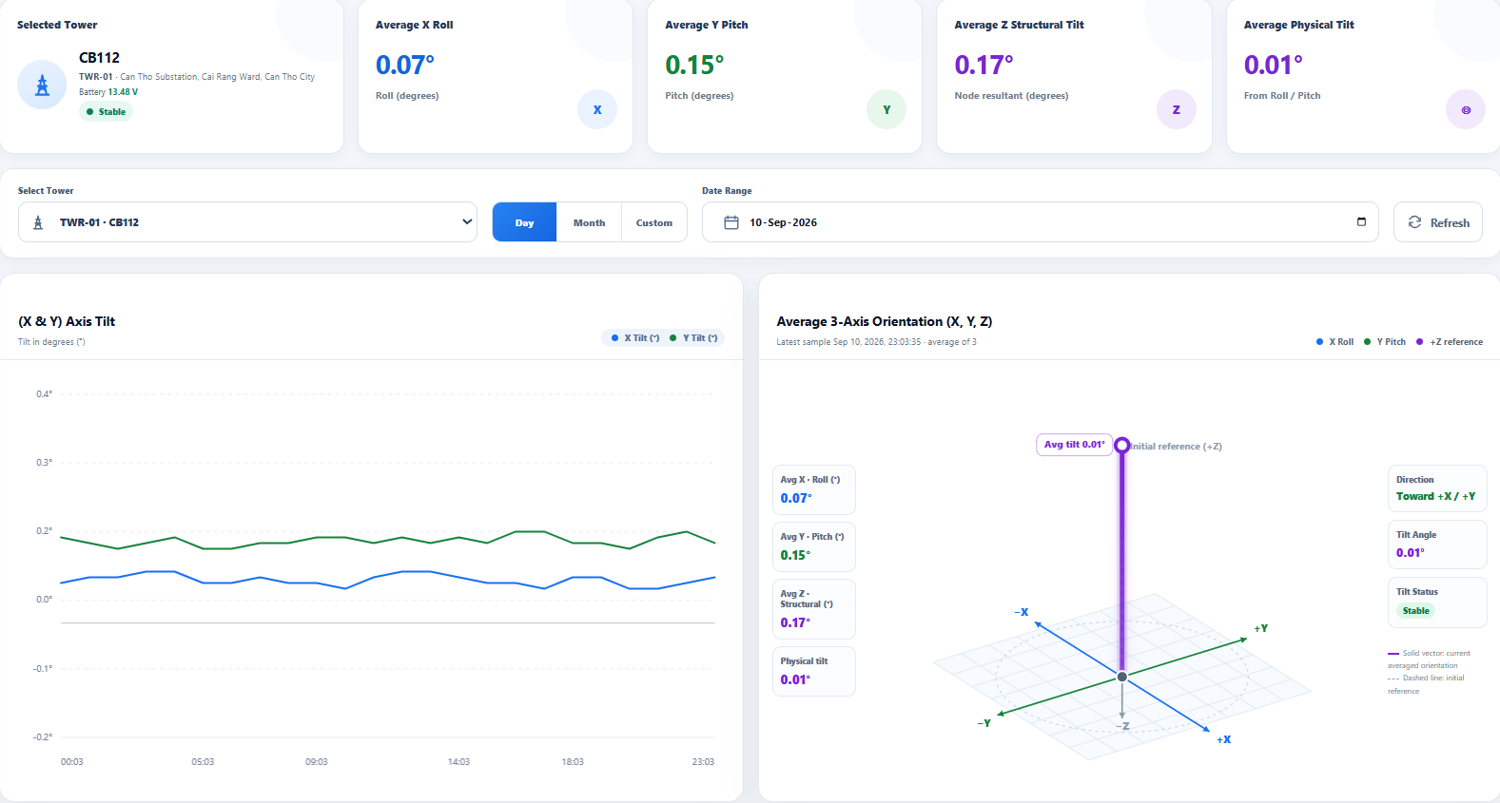

(b)

Figure 12. Recorded data on the Web Dashboard: a) Date 9/9/2026; b) Date 10/9/2026

The Web Dashboard interface displays real-time tilt monitoring parameters for the CB112 circuit breaker foundation at the Can Tho 220kV Substation across two consecutive days, September 9, 2026, and September 10, 2026. The dashboard layout integrates key average metric cards (X Roll, Y Pitch, Z Structural Tilt, and Physical Tilt), a time-series plot depicting two-axis tilt variations (X & Y Axis Tilt), and a 3D spatial model visualizing the actual tilt vector orientation (Average 3-Axis Orientation). The observed results demonstrate high consistency and stability over the monitoring period: the average X Roll remained constant at 0.07 degree, while the Y Pitch slightly varied from 0.14 degree (Sep 9) to 0.15 degree (Sep 10), corresponding to a total Z Structural Tilt ranging between 0.16 degree and 0.17 degree. The time-series curves show smooth, nearly parallel trajectories without anomalous spikes, and the 3D model confirms a predominant tilt orientation toward the +X/+Y direction. Throughout the observation window, the overall structural health status continuously evaluated as 'Stable', remaining well below the Warning threshold of 0.3 degree.
3.5. Discussion
Field monitoring results at the high-voltage substation confirm the high efficiency and stable operational performance of the MPU-6050-based tilt monitoring system. Despite operating in a harsh environment characterized by severe electromagnetic interference (EMI) from high-voltage equipment and significant outdoor temperature fluctuations, the continuous 66-hour time-series data maintained exceptional stability, exhibiting an extremely low tilt variation amplitude (less than 0.04 degree). The integration of the complementary and Kalman filtering algorithms successfully eliminated high-frequency ambient noise while completely suppressing cumulative zero-drift across all monitored axes. Furthermore, the standalone solar power system demonstrated complete energy sustainability through a stable daily charge-discharge cycle (with supply voltage fluctuating between 13.24 V and 14.42 V), ensuring continuous 24/7 autonomous operation without requiring a connection to the substation's auxiliary power grid.
The tilt angle values collected from this system are used to monitor the structural stability trend of the circuit breaker foundation in real time. They also serve as a basis for managers to plan subsequent corrective actions if the recorded tilt angles exceed safe operational limits. In such cases, dedicated monitoring equipment may be deployed in parallel for a comprehensive inspection to ensure the safe operation of the power system.
Despite the successful field deployment, the proposed monitoring system exhibits three main technical limitations that warrant further improvement. Firstly, the solar energy harvester is currently installed at a low elevation with a fixed tilt angle, rendering it vulnerable to shading effects from nearby high-voltage steel structures, which impairs overall energy charging efficiency. In addition, the MPU-6050, as a low-cost MEMS sensor, lacks an integrated magnetometer, causing long-term orientation tracking to rely solely on the gyroscope and introducing a risk of cumulative drift over extended operational periods. Moreover, although LoRa communication offers exceptional long-range and low-power performance, it increases susceptibility to packet loss under severe electromagnetic interference (EMI) within the 220kV substation.
To enhance the system's operational reliability and scalability in high-voltage substation environments, future research will focus on four key technical enhancements:
- Solar Panel Optimization: Elevating the solar panel mounting safety position on the tower structure to completely eliminate shading effects from surrounding equipment to maximize energy harvesting efficiency under adverse weather conditions.
- Edge AI Integration: Embedding lightweight machine learning algorithms directly onto the edge microcontroller to analyze real-time acceleration and angular velocity data. This enables on-device classification between transient structural vibrations (caused by wind gusts or circuit breaker operations) and permanent structural tilt/ subsidence, thereby significantly reducing false alarm rates.
- Sensor Suite Upgrade: Upgrading the sensing module to an advanced 9-axis AHRS sensor (e.g., MPU-9250 or BNO055) equipped with an integrated magnetometer and Extended Kalman Filtering (EKF) to eliminate cumulative gyroscope drift during long-term field deployment.
- Cellular Integration: Deploying a cellular module alongside LoRa to establish hybrid communication architecture. This improves bandwidth, reduces latency, and guarantees uninterrupted real-time data transmission even under severe electromagnetic interference (EMI) or beyond the line-of-sight range of LoRa Gateways.
4. CONCLUSION
This study successfully developed, deployed, and evaluated a real-time tilt monitoring system based on the MPU-6050 sensor at the 110kV circuit breaker foundation of the Can Tho 220kV Substation after 8 years of operational service. Continuous 66-hour field experimental results (from September 8 to September 11, 2026) confirm superior structural stability, recording mean tilt angles of X = 0.08⁰, Y = 0.14⁰, and a total absolute tilt angle of Z is about 0.16⁰ with extremely low variation (less than 0.04⁰). The integration of complementary and Kalman filtering algorithms effectively eliminated high-frequency ambient noise and cumulative zero-drift under severe electromagnetic interference (EMI) conditions. Furthermore, the standalone solar power system demonstrated sustainable performance across a 13.24 V - 14.42 V voltage cycle, guaranteeing continuous 24/7 autonomous operation. Although minor limitations persist regarding solar shading, long-term gyroscope drift, and LoRa connection stability, proposed future enhancements, including solar panel positioning optimization, Edge AI integration, 9-axis sensor upgrades, and Cellular connectivity deployment, will refine the system, paving the way for widespread adoption in structural health monitoring for smart grids.
ACKNOWLEDGEMENT
This work was supported by Can Tho University (CTU) under Research Grant No. T2026-69, dated June 1, 2026. The authors express their sincere gratitude to CTU for providing the research facilities and time dedicated to this study.

REFERENCES
- Dung, L. N., Quynh, B. D., Khanh, P. Q., Long H. V., and Oanh, D. T. (2021). Assessment of tilt monitoring by portable tiltmeter in Vietnam. Journal of Science and Technology in Civil Engineering. 15(1V), pp: 134-145.
- Dung, L. N., Quynh, B. D., Nghiem, N. D. (2020). Assessment of monitoring work of diaphgram wall by inclinometer in Vietnam. Journal of Science and Technology in Civil Engineering. 14(2V), pp: 152-161.
- Liu, R., Pei, H., Chen, C., Tian, Z. and Hao, C. (2021). Research on inclination monitoring technology of transmission tower based on UAV. Journal of Physics: Conference Series, ICEECT. 2030, 012076. doi:10.1088/1742-6596/2030/1/012076.
- Yang, Y., Wang, M., Wang, X., Li, C., Shang, Z. and Zhao, L. (2023). A novel monocular vision technique for the detection of electronic transmission tower tilting trend. MDPI applied sciences. Vol 13. 407. Doi: 10.3390/app13010407.
- Lu, Z., Gong, H., Jin, Q., Hu, Q. and Wang, S. (2022). A transmission tower tilt state assessment approach based on dense point cloud from UAV-based LiDAR. MDPI remote sensing. Vol. 14. 408. Doi: 10.3390/rs14020408.
- Zhang, G., Liu, M., Cheng, S., Wang, M., Zhao, C., Zhao, H. and Zhong, G. (2023). Research on transmission line tower tilting and foundation sate monitoring technology based on multi-sensor cooperative detection. Energy engineering. Vol. 121, pp. 169-185. Doi: 10.32064/ee.2023.027907.
- Wang, L., Liu, C., Zhu, X., Xu, Z., Zhu, W. and Zhao, L. (2021). Active vibration-based condition monitoring of a transmission line. MDPI actuators. Vol 10. 309. Doi: 10.3390/act10120309.
- Hu, X., Pei, H., Liu, B., Wang, C. and Hao, C. (2021). Real time warning model of transmission tower tilt based on multi-sensor data. Fuzzy systems and data mining VII. 10.3233/FAIA/210220.
Dias, C. F., Oliveira, J. R. D., Mendonca, L. D. D., Almeida, L. M. D., Lima, E. R. D. and Wanner, L. (2021). An Iot-based system for monitoring the health of guyed towers in overhead power lines. MDPI Sensors. Vol.21, 6173. doi:10.3390/s21186173.
Qian, K. and Wang, J. (2025). Spatial visualization monitoring method of tower tilt of isolated transmission lines based on PSO-GRNN. Results in Engineering. https://doi.org/10.1016/j.rineng.2025.106707.
Socialist Republic of Vietnam. (2025). National Technical Regulation on Electric Power Technical – Power Network (QCVN 26:2025/BCT). https://www.evn.com.vn/userfile/User/minhhanh/files/2025/12/QCVN-26-2025-20251201152537687_BCT%20Ky%20thuat%20dien%20-%20He%20thong%20luoi%20dien.pdf.

